**Distributing common framework repository to**

**Artifactory for consumption of individual application hanrnesses through maven distribution management features**

|  |  |  |  |
| --- | --- | --- | --- |
| Version | Author | Date | Remarks |
| 0.1 | Atul Gogte | 26th Nov 2016 | initial draft version |
| 1.0 | Atul Gogte | 30th Nov 2016 | Baselined after testing the functionality on few more machines. |

**Step 1 - Adding settings.xml**

We have created an **artifactory repository** on our local artifactory server (<http://kstlitqavm033.corp.chartercom.com:8081/artifactory/>) called as **libs-release-local**.

In order to deploy to this repopsitory you must do folloing things

1. Copy **settings.xml** file from X drive - \\192.168.92.69\ossautomation$\Automation\Z-atul\Maven Distribution\



1. Add **settings.xml** under your **<user_home>/.m2** folder (*No need to change anything in the file*)

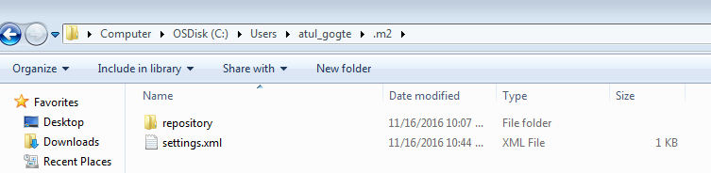

**Step 2 - Updating Framework pom.xml**

Please add the folling sections in framework pom.xml

*NOTE: this has already been done. The POM.xml file in the Framework repository in GitHub has already been commited. So in order to see the below changes, you just need to do a pull on Framework repository.*

*<!--defining the naming convention for framework repository --****>***

<groupId>com.chtr.tmoauto</groupId>

<artifactId>Framework</artifactId>

<version>2.0</version>

*<!-- define path for deployment to artifactory repository -->*

<distributionManagement>

<repository>

<id>central</id>

*<name>KSTLITQAVM033-releases</name>*

*<url>http://kstlitqavm033.corp.chartercom.com:8081/artifactory/libs-release-local</url>*

*</repository>*

*</distributionManagement>*

After adding these sections to framework repository pom.xml, you can deploy the framework artifact to remote public repository using **mvn deploy** command.

What it does is upload your project artifacts to artifactory repository as shown below.

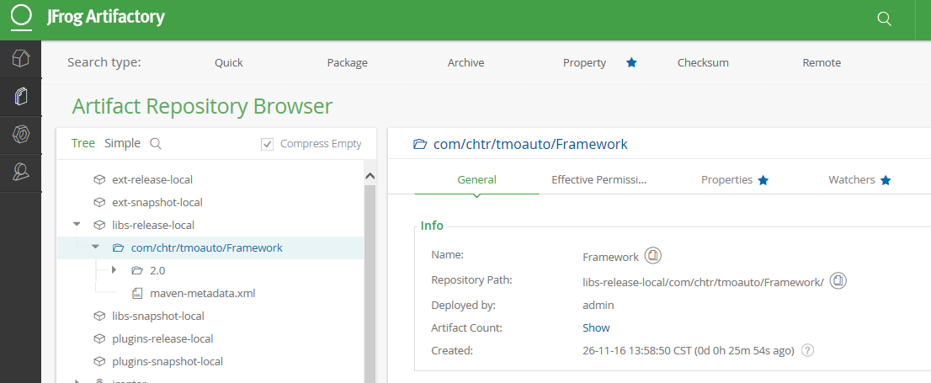

**Step 3 - Updating Application level pom.xml**

Add following sections in your application level pom.xml allowing your application to refer to third party external repository (along with maven central repopsitory) to access the framework functions.

<repositories>

<!-- This allows application pom to refer to our public framework repository -->

<repository>

<id>central</id>

<url>http://kstlitqavm033.corp.chartercom.com:8081/artifactory/libs-release</url>

<snapshots>

<enabled>false</enabled>

</snapshots>

</repository>

</repositories>

<!-- Add following dependency to framework functions from public repository -->

<dependency>

<groupId>com.chtr.tmoauto</groupId>

<artifactId>Framework</artifactId>

<version>2.0</version>

</dependency>

Now run the **mvn clean package** command on your application project.



This will **downlaod framework-2.0 .jar from Artifactory repository to your local .m2 reository** as shown below

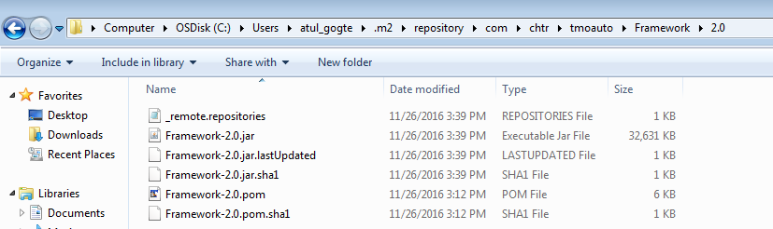

Now you can reference the common framework functions insite your application project inside your IDE

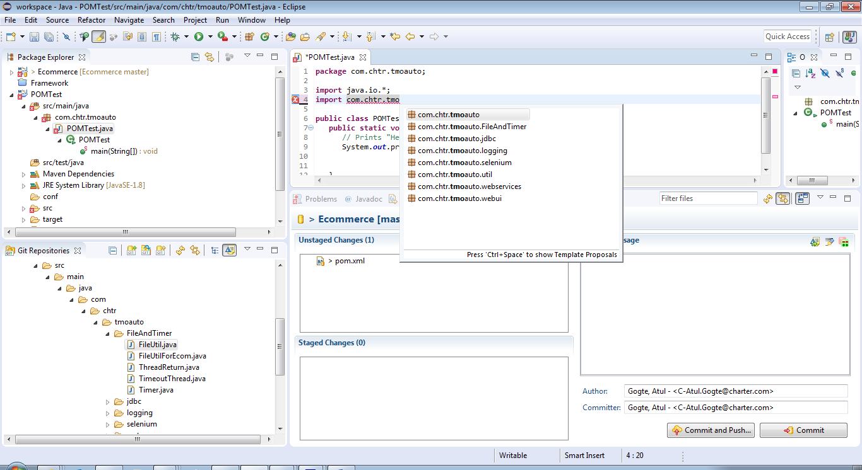

Right After Artifactory bulid and right BEFORE Jenkins execution, navigate to kstlitqavm033

Navigate to C:\Windows\SysWOW64\config\systemprofile\.m2\repository\com\chtr\tmoauto

Delete the Framework folder and all content under it.

**Maven Deploy to Artifactory**

To do a maven deploy.

1. Commit most recent changes into Framework GitHub repository
2. In DOS prompt, go to local directory: C:\Users\svc_automation\git\framework
3. mvn deploy

it should update artifactory with the latest Framework jar file.